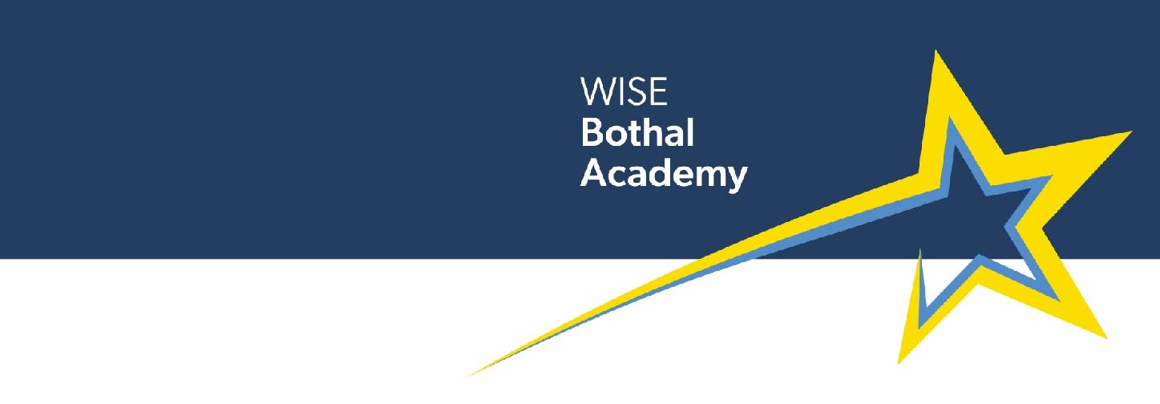

9 July 2026

Dear Parent/Carer

Musical Instrument Tuition for Children on Upper Site – September 2026
We would like all our pupils to have an opportunity to learn to play a musical instrument. The skills learned not only support a child’s musical abilities, but also have an impact on their motor skills, literacy and numeracy.

This is a voluntary activity and not part of normal school music lessons. These lessons take place during the school day and consist of ten 30-minute lessons for which a payment of £62.50 per term must be made. If you are entitled to free school meals, you may be able to have help with the costs of lessons so please contact us to discuss this. Your only other expense may be some pieces of music from time to time and the cost of an instrument should you wish to hire one. We hold instruments in school that pupils are able to use during tuition sessions.

Our peripatetic music teacher Mr Muckle will deliver the lessons in school and will offer tuition in guitar (including ukulele and bass), keyboard (including piano) and drums (including djembe).

If you would like any more information before deciding to sign up for tuition, please do not hesitate to contact us.

To register your child’s interest in taking part please complete the slip below and return to school by Wednesday 15 July. Please DO NOT send any money to school until we request this in September.

Yours sincerely

C Duncan

Mrs C Duncan
Office Manager

-------------------------------------------------------------------------------------------------------------
PLEASE RETURN TO SCHOOL BY WEDNESDAY 15 JULY (DO NOT ENCLOSE PAYMENT YET)

Name of Child: ____________________________________ Class: ___________

My child is interested in music lessons starting in September and their preference would be: Please tick one option only, if your child decides to change instrument during the term this can be arranged as long as we have parental permission.

Keyboard (including Piano)
Guitar (including Ukulele and Bass)
Drums (including Djembe Drums)

Signed: _____________________ Name: ______________________________(Parent/Carer)

