


In the Autumn term children will be learning:

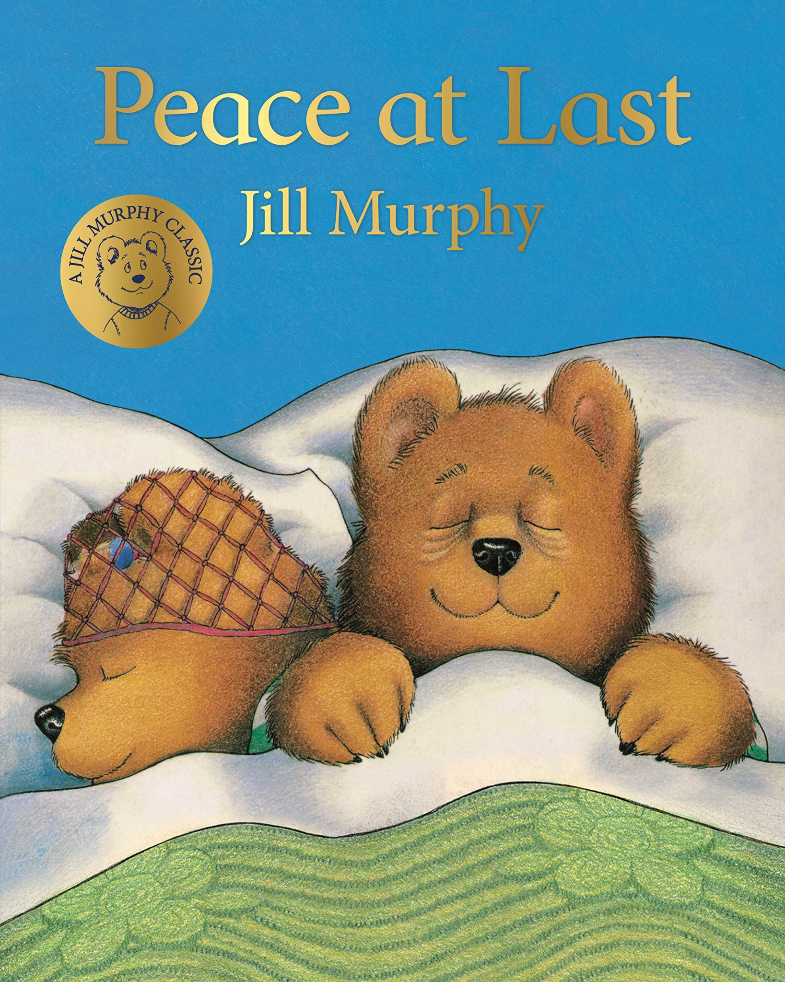
Core Books |  | 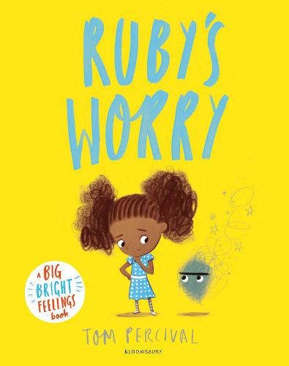 | 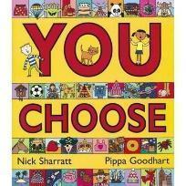 | 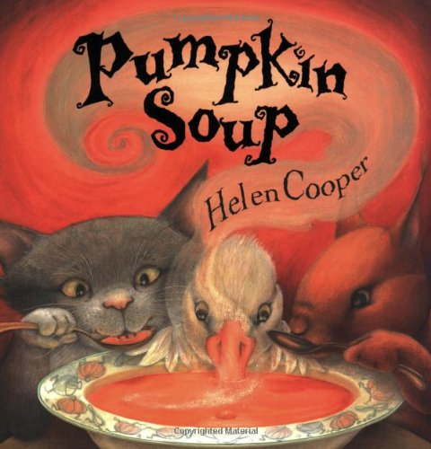 |  |  |  |  |  | 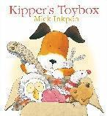 |  |  | 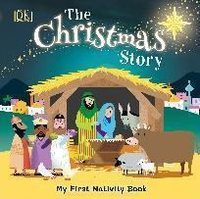
Communication and Language  - Listening, attention and understanding  - Speaking |  | Communication and Language skills will be developed this term with a strong focus on developing vocabulary and conceptual understanding. Literacy sessions focus on developing speaking and listening skills. We use Launchpad for Literacy as our approach in order to identify speech, language and other developmental needs as soon as possible and to embed specific skill-based intervention into practice and Quality First Teaching.
- Practitioners set expectations for listening when others are speaking.
- Introduce new vocabulary using language plans to support.
- Encourage children to look at the pictures from the story independently and say what they see and make conversation based around the pictures.
- Encourage children to use new language in context
- Play group games to encourage communication.
- Sing a range of familiar Nursery rhymes
- I can talk about my favourite part of a familiar book.
- I can use longer sentences of four to six words.
- I can question why things happen and give simple explanations, Asks, e.g. who, what, when, how.
- I understand ‘why’ questions, like: “Why do you think the caterpillar got so fat?”

Personal, Social and Emotional Development  - Self regulation  - Managing self  - Building relationships |  | This term focuses on settling into our new class and meeting new friends. We will look at who we are as individuals and what makes people special, celebrating similarities and differences. In Reception, the Jigsaw PSHE scheme is used to support planning. The children cover the units Being Me in My World and Celebrating Differences.
 |  | -Feelings of worry.  -Importance of friendships.  -Who to talk to if you have a worry. | -Share likes and dislikes.  -Talk about our families and explore similarities and differences.  -Discuss healthy and unhealthy food choices. | -The importance of sharing.  -Explore ways to manage disagreements.  -Explore fair and unfair scenarios.  -Recap healthy eating choices, specific focus on vegetables. |  |  | -Resilience - how do we overcome problems? |  |  | -What is special to us?  -Discuss feelings of loss and worry.  -How can we look after our things so we don’t misplace them? |  |  | -Respecting the beliefs of others.  -Giving - what can we do for others?
Physical Development  - Gross motor skills  - Fine motor skills |  | In Reception we use the hall/outdoor space to deliver whole class sessions PE lessons that focus on developing fundamental movements. We also develop our gross motor skills through daily access to our outdoor area. Practitioners model specific skills children need to master to complete each obstacle/ activity. The children have access to a range of surfaces to feel, move and balance on. Our Reception provision (indoors and outdoors) provides a choice of open-ended materials that allow for extended, repeated and regular practising of physical skills like lifting, carrying, pushing, pulling, constructing, stacking and climbing. Activities to promote fine motor development are a key part of our provision and are essential to aid children’s journey to becoming a writer. Children are encouraged and directed to fine motor activities to improve their hand strength and control.
 |  | Gross Motor Skills |  |  |  |  | Fine Motor Skills
 |  | - I am increasingly able to use and remember sequences and patterns of movements which are related to music and rhythm.  - I can skip, hop, stand on one leg and hold a pose for a game like musical statues.  - I can match my developing physical skills to tasks and activities in the setting. For example, I decide whether to crawl, walk or run across a plank, depending on its length and width.  - I can collaborate with others to manage large items, such as moving a long plank safely, carrying large hollow blocks.  - I can grasp and release with two hands to throw and catch a large ball, beanbag or an object. |  |  |  |  | - Model correct letter formation and provide a range of tools to encourage writing and drawing.  - Model using tools to manipulate clay into simple models.  - Observational drawing activities are set up, children are supported to add finer details to their work.  - I have developed my small motor skills so that I can use a range of tools competently, safely and confidently. Suggested tools: pencils for drawing and writing, paintbrushes, scissors, knives, forks and spoons.  - I am beginning to form a range recognisable letters independently inline with phonics/handwriting lessons.
PE
Autumn 1- Walking and Jumping:
Children will explore walking using different body parts in different directions, at different levels and at different speeds.
Children will explore how we walk using our head, arms and feet, applying an effective walking technique.
Children will apply their understanding of walking, applying it into a game.
Children will explore jumping and hopping, in different directions, at different speeds and different levels, applying a basic jumping technique.
Children will explore jumping for distance and height.

Autumn 2- Team building: Ball skills (hands):
Children will explore different ways of pushing, bouncing and rolling a ball.
Children will learn the meaning of the word ‘control’ and start to understand why it is important to keep the ball close to them.
Children will work with a partner and begin to understand why it is important to be part of a team.
Children will learn the meaning of the word defender and what this means when playing games.

Literacy  - Comprehension  - Word reading  - Writing |  | Daily phonics sessions are ongoing this term, focusing on Set 1 letters from the Read, Write Inc programme. Sounds are recapped consistently through Pinny Time. Blending and segmenting of simple words using these sounds are reinforced daily through Fred talk games. Early Literacy skills gaps are identified through Launchpad for Literacy and opportunities to bridge these gaps are provided through informed intervention. Daily story sessions play an important part of the day where both new and familiar stories are shared.
- Children are taught a new sound daily in their phonics lessons.
- Fred games – segment spoken words for children to blend together.
- Story ordering- focusing upon the beginning, middle and end.
- Whole class story retell using story map.
- Revisit previous story maps from Nursery.
- Children can orally segment a CVC word and build it with the correct letters.
- Children are beginning to form a range of recognisable letters independently inline with phonics/handwriting lessons.
- Emergent writing: I can use some of my print and letter knowledge in my early writing. For example: writing a pretend shopping list that starts at the top of the page; writing ‘m’ for mummy.
 |  | -Draw an image of Ruby. | -Create a comic strip using pictures from the book. | -Look at different types of instructions; recipes, building furniture.  -Model following instructions for a purpose through making pumpkin soup as a class. |  |  | -Story ordering, focusing upon the beginning, middle and end.  -Orall compose CVC words. |  |  | -Write a character list.  -Describe your own special toy. |  |  | -Christmas performance oral story retell through songs.
Mathematics  - Number  - Numerical pattern |  | We follow the Mastering Number maths scheme in Reception. Children are introduced to and encouraged to use manipulatives to support their mathematical understanding and to explain their thinking.
Subitising:
-Perceptually and conceptually subitise within 3 and then within 5 (Autumn 2).
-Identify subgroups in larger arrangements.
-Create their own patterns for numbers within 4.
-Practise using their fingers to represent quantities which they can subitise.
-Experience subitising in a range of contexts, including temporal patterns made by sounds.
Cardinality:
-Relate the counting sequence to cardinality, seeing that the last number spoken gives the number in the entire set.
-Have a wide range of opportunities to develop their knowledge of the counting sequence (rote counting), including through rhyme and song.
-Have a wide range of opportunities to develop 1:1 correspondence, including by coordinating movement and counting.
-Have opportunities to develop an understanding that anything can be counted, including actions and sounds.
-Explore a range of strategies which support accurate counting.
-Explore the cardinality of 5, linking this to dice patterns and 5 fingers on 1 hand.
-Begin to recognise numerals, relating these to quantities they can subitise and count.

Composition:
-See that all numbers can be made of 1s.
-Compose their own collections within 4.
-Explore the concept of ‘wholes’ and ‘parts’ by looking at a range of objects that are composed of parts.
-Explore the composition of numbers within 5.

Comparison (inc. Measures):
-Understand that sets can be compared according to a range of attributes, including by their numerosity.
-Use the language of comparison, including ‘more than’ and ‘fewer than’.
-Compare sets using a variety of strategies, including ‘just by looking’, by subitising and by matching.
-Compare sets by matching, seeing that when every object in a set can be matched to one in the other set, they contain the same number and are equal amounts.

Pattern:
-Extend and create AB patterns of different types e.g. quantity, colour, orientation of objects, growing patterns (quantity increases each time).
-Make a specified pattern (make a green/yellow pattern). Choose their own rule for a pattern and create it.
-Spot an error in an AB pattern.
-Identify the unit of repetition, e.g. spot a red/ blue pattern or a circle/triangle pattern.

Shape and space:
-Show increasing intentionality in selection of shapes e.g. using cylinders for shapes and purpose (they can roll).
-Become increasingly familiar with and use language to describe the properties: curvedness, number of sides and corners (2D), faces, vertices, edges (3D).
-Recognise triangles, rectangles in a range of representations and orientations (not always as regular shapes).
-Know that a square is a type of rectangle.
-Select, rotate and manipulate shapes to develop spatial reasoning skills.
Understanding the World  - Past and present  - People, culture and communities  - The natural world |  | In this term, we look for changes that occur during Autumn to support our scientific understanding. Children are encouraged to be curious and to ask questions – stimulating a sense of excitement about natural phenomena and developing the foundations of scientific enquiry. We find out about different festivals such as Diwali and Christmas and how people celebrate them. We explore a range of technological toys and equipment.
 |  | -Safe people to talk to in our local community.  - | -Our local area- Ashington.  -Features of our local environment.  -Map our journey to school.  -Talk about where we live and different homes.  -Talk about careers, drawing on the pages from the book. | -Grow a pumpkin.  -Make pumpkin soup.  -Teach about Harvest.  -Where does food come from?  -Observe seasonal changes. |  |  | -Night and day- changes over time.  -Environmental sounds. |  |  | -Shadows.  -Explore old and new toys.  -Which material is best to make a toy box from? |  |  | -Teach the Christian story of the first Christmas.  -Respecting the beliefs of others.
Expressive arts and design  - Creating with materials  - Being imaginative and expressive |  | Through stories, role play and small world play, we extend opportunities to explore imagination. Creative materials such as paint, dough and collage are used to explore colour and texture. Music and movement experiences are ongoing too, through the use of instruments and regular songs and rhymes. Children can play cooperatively as part of a group to create, develop and act out imaginary ideas or narrative.
 |  | -Model how to access the creative areas appropriately. | -Painting/ drawing of a feature of our local area. | -Use objects from the natural world to create pictures that represent autumn.  -Observational drawings of vegetables  -Model mixing colours together to achieve a desired colour to paint observational drawings of vegetables. |  |  | -Mix paints for purpose to create the correct colour.  -Paint a picture of a house.  -Manipulate clay to create a bear. |  |  | -Use junk modelling to design and build a toybox  -Create their own ‘sock thing’.  -Toy shop role play area |  |  | -Design wrapping paper.  -Make a Christmas card.

