



In the Autumn term children will be learning:

Core Books
 | 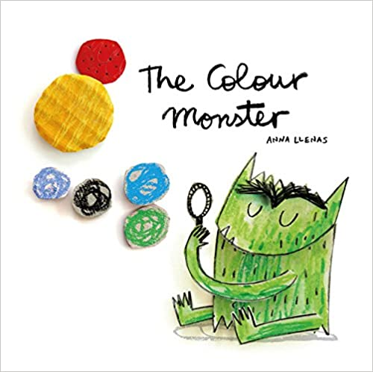 | 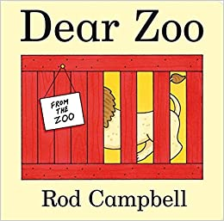 | 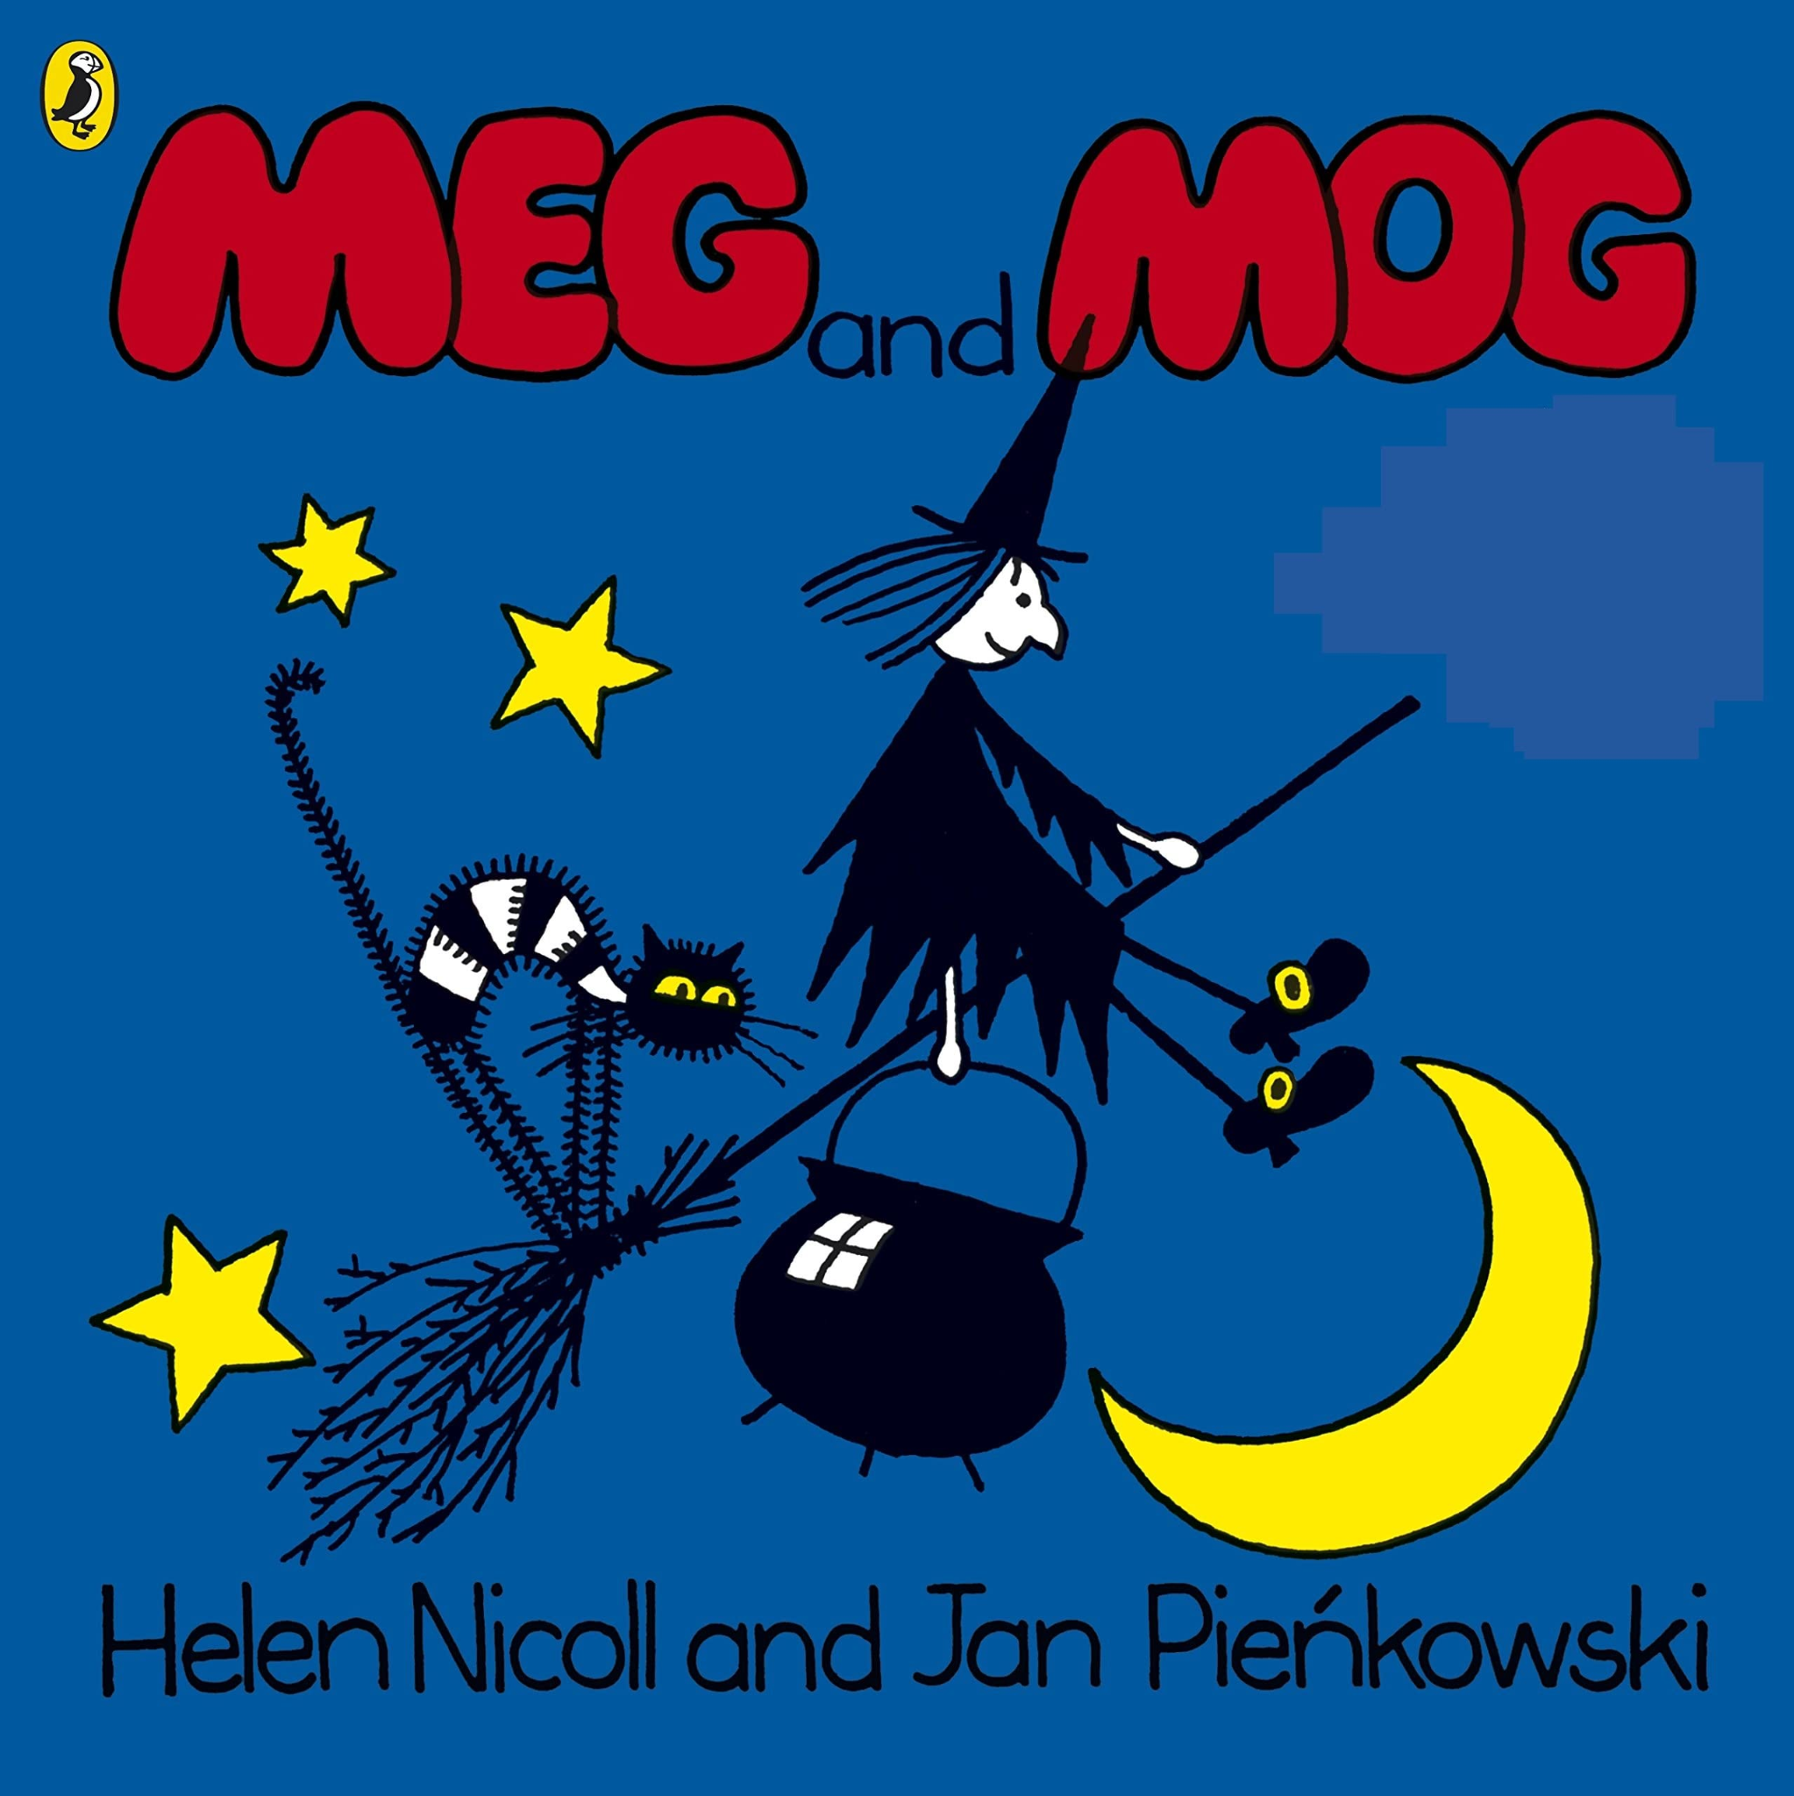 |  |  | 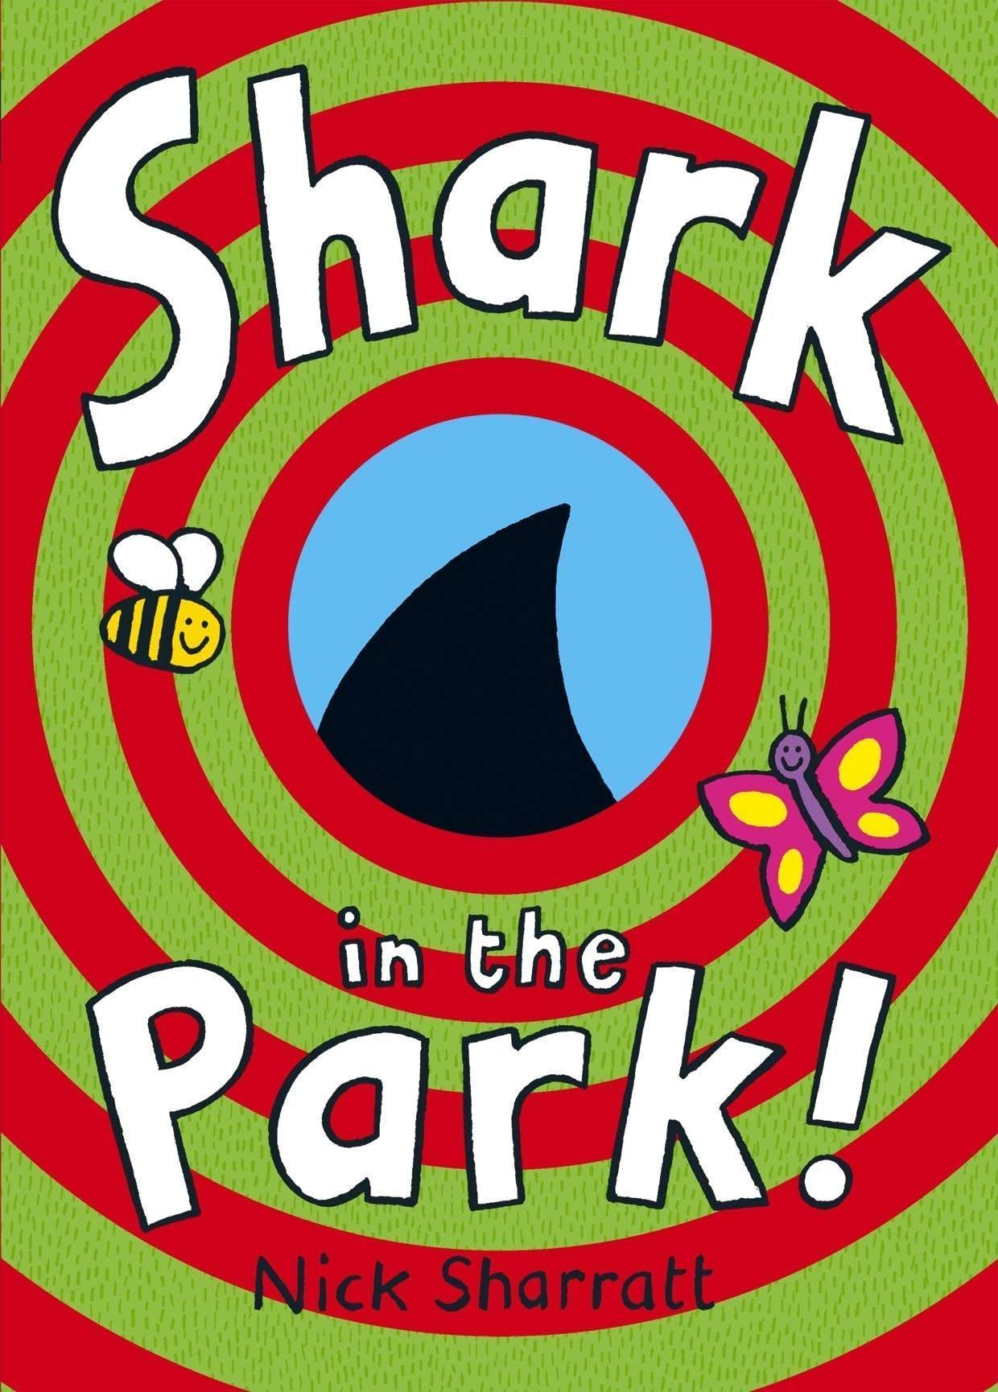 |  |  | 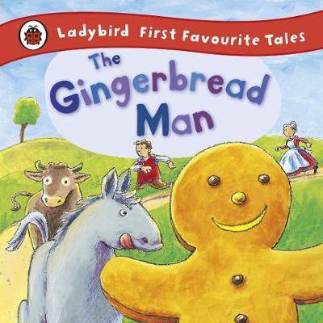 | 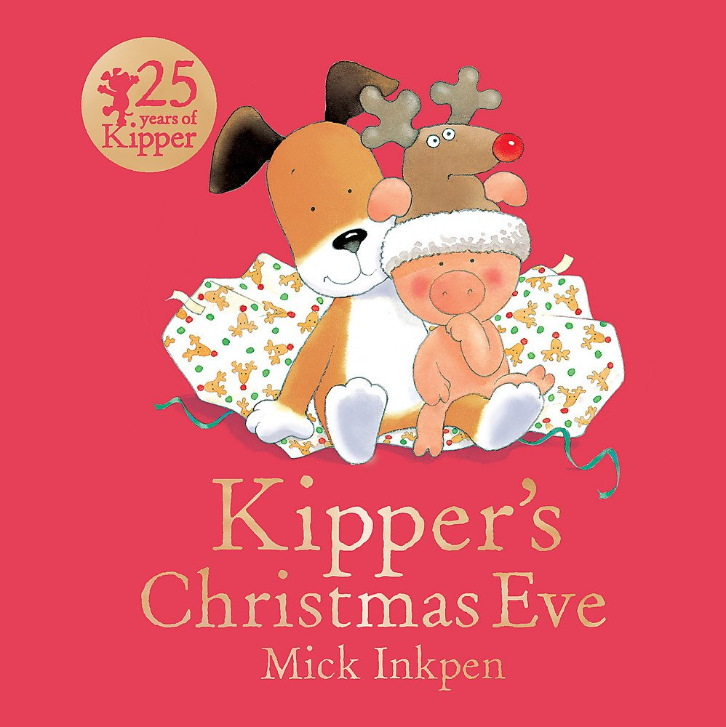
Communication and Language  - Listening, attention and understanding  - Speaking | Within the WISE Trust we take great pride in ensuring we provide a language rich environment which is accessible to all of our learners. Communication and language skills will be developed this term by beginning with establishing listening skills, learning to listen to practitioners and peers when they are talking. Practitioners will model new vocabulary in context and provide opportunities for the children to practise the language in the environment through meaningful and memorable experiences. New vocabulary is carefully planned and considered through the use of our language plans. The children will listen to and become familiar with a variety of key texts and be encouraged to join in with the repeated refrains. An early awareness of rhyme will begin to form through the emphasis of rhyming words in familiar stories, E.g. Meg and Mog and Shark in the Park!. The children will be given opportunities to anticipate key phrases or events and to finish rhyming couplets in familiar stories and songs. My turn, your turn will be modelled from an early stage using auditory and visual prompts to encourage turn taking. We use Launchpad for Literacy as our approach in order to identify speech, language and other developmental needs as soon as possible and to embed specific skill-based intervention into practice and Quality First Teaching.
Personal, Social and Emotional Development  - Self regulation  - Managing self  - Building relationships | This term focuses on settling into our Nursery classes, building relationships with practitioners, meeting new friends and learning Nursery rules and expectations. Children will develop an identity within the Nursery. For example, they will know where their peg is, know what belongs to them and know that they can make choices within their play. Children will learn how to respect the learning environment (for example, where toys and resources are stored) and will become familiar with behavioural expectations in the setting. This is heavily modelled by practitioners. Children will begin to learn self regulation strategies using the Thrive principles (VRFs). Children will learn to attend to their basic self care needs, e.g. using the toilet and washing their hands. Practitioners will create opportunities for conversation, turn-taking and sharing, and will model appropriate responses frequently. For example, simple turn taking games will be on offer. Children will be taught to wait their turn, sometimes with adult support. In Nursery, the Jigsaw PSHE scheme is used to support planning. The children cover the units Being Me in My World and Celebrating Differences.
Physical Development  - Gross motor skills  - Fine motor skills | This term we will focus on developing both gross and fine motor skills. Children will develop these skills through access to both indoor and outdoor provision. The children can choose to access daily fine motor challenges throughout a range of the available activities and areas. The specific skill is modelled by practitioners accordingly. For example,activities may include opportunities to pour, lace, thread, cut and mark make. Children will participate in whole class/small group sessions of “dough disco”, yoga and skill-based physical sessions. Children will be provided opportunities to use large equipment and to explore large open areas. They will be given access to a range of large stationary and movable equipment including bikes, scooters, climbing apparatus, tyres, etc. Children take part in a daily circuit that includes crawling, balancing and jumping.
Literacy  - Comprehension  - Word reading  - Writing | The children will focus on a range of key texts, as seen above. Storytime is a valued part of every Nursery session. Practitioners will explore favourite and new books and encourage discussions around the story by talking about the characters and settings and by asking simple questions about the plot. The children will be motivated to join in with repeated refrains in familiar stories. The children will take part in simple story retellings of our key texts through story mapping. The children will learn the simple story script alongside learning Makaton signs for key words and then work with practitioners to develop a story map to aid recall. This will support the children’s auditory memory, sequential auditory memory and vocabulary understanding. Launchpad for Literacy will be used to develop early literacy skills, planned sessions will focus upon recognising rhythm in words and beginning to orally blend compound or two syllable words. Syllable clapping will be modelled when introducing new words. Practitioners will model creating marks for a purpose whilst talking about the marks they make. The children will be encouraged to distinguish between their marks and ascribe meaning as they draw or write. The children will begin to realise that writing and drawing are different. They will have access to a range of resources to motivate them to make marks, e.g. clipboards and notepads. Children can draw a person on request and copy pre writing shapes.
Mathematics  - Number  - Numerical pattern | Stories, songs and rhymes are used to promote mathematical understanding. Opportunities for incorporating maths into the daily routine are maximised (for example, during registration and snack times). Children will perceptually subitise groups of 2 and begin to notice patterns of 3 objects. They will recite numbers in order to 5 and begin to link the counting system to cardinality (the last number counted is the total amount). Children will practise making comparisons, e.g. between quantities, size and comment when something is the same or different. The children will also be given the opportunity to develop their spatial reasoning skills, including space, shape and measures. This term, the children will notice and join in with auditory patterns and begin to say what comes next in an AB pattern. They will explore 2D shapes and begin to learn their mathematical name and their properties. There will also be a clear focus on developing children’s mathematical vocabulary in relation to size, shape, pattern, weight, time and capacity.
Understanding the World  - Past and present  - People, culture and communities  - The natural world | Nursery routines will be established from the outset. The children will begin to develop a sense of time through planned opportunities to anticipate familiar events and talk about what they have done each day and throughout the week using pictures and prompts. We will begin to explore similarities and differences between ourselves and explore a range of different occupations. Related vocabulary will be modelled and encouraged by practitioners during role-play and conversation. Attention will be drawn to the natural world around us. We will observe seasonal changes by using our senses. The children will observe the effect of wind through a range of investigations and experiences.
Expressive arts and design  - Creating with materials  - Being imaginative and expressive | Role-play areas will be carefully set up to ensure the children can engage in pretend play, based on their own experiences. Practitioners will stimulate the children’s imagination through sharing experiences and stories. The children will be familiar with Nursery rhymes and songs as they are embedded into the Nursery routine. There will be a range of opportunities to explore a wide range of creative materials. The children will be taught to use colours for a purpose and how to join materials to create models to express their ideas.

